First, run the server, then, run the client, type any String in the client and it will get the same String back from the server.

When the user type “quit!”, both the server and client will quit immediately.

This is the server:

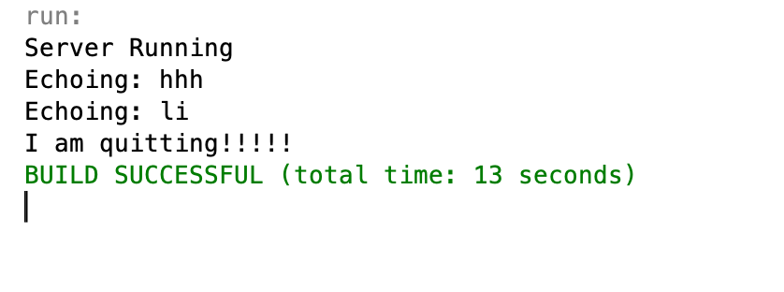

This is the client:

